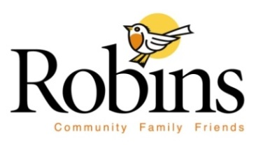

Tentative Agenda

Robins City Council
Monday, March 4th, 2024
4:00 p.m. @ Robins City Hall

(One or more members of the Council may be attending via Electronic Device)

Agenda:
- Call the Meeting to Order
- Roll Call
- Approval of the Agenda
- Business Items:
- Finalize the FY ’25 Municipal Budget
- Resolution No. 0324-1 setting a public hearing to approve the FY ’25 General Fund Proposed Property Tax Levy.
5. Motion to adjourn

