January 13, 2023

RE: West Main Street Reconstruction and Trail

Dear Robins Resident,

The City of Robins is hosting an informal open house to discuss the proposed West Main Street Reconstruction and Trail project and help answer questions you may have. The open house will be on Tuesday, February 7th, from 5:00-7:00 pm at Robins City Hall, 265 S. Second Street. Exhibits showing plan layouts will be displayed and project engineers will be available to answer questions you may have with regard to the project or potential impacts to your property.

As part of this project, West Main Street will be reconstructed from Stamy Road to the Cedar Valley Nature Trail. The project will also include the construction of a trail along West Main Street and Stamy Road. See the reverse side of this page for additional information related to the project including a project map.

Please find the enclosed questionnaire of requested information and optional feedback for the project. If you wish, please complete the form and return to City Hall for consideration by the design team. If you have any questions about this project but are unable to attend the open house, you may contact the project engineer, Dax Suntken, at 319-362-9394. If you require any special accommodations in order to attend this open house, please contact City Hall at 319-393-0588 to make proper arrangements.

Sincerely,

SNYDER & ASSOCIATES, INC.

Dax Suntken, P.E.
Project Manager

PROJECT INFORMATION
_____________________________________________________________________________

SUMMARY OF IMPROVEMENTS: This project will include reconstruction of West Main Street from a rural two-lane section to an urban section, with curb and storm sewer. The limits of this project along West Main Street are from Stamy Road to the Cedar Valley Nature Trail. A 10-foot-wide trail will be constructed on the north side of West Main Street and along the west side of Stamy Road which will be extended by future projects to loop to the Cedar Valley Nature Trail. A 5-foot-wide sidewalk is planned on the south side of West Main Street.

PROJECT TIMELINE: Construction schedule is to be determined depending on potential funding assistance.

WILL STREETS BE CLOSED DURING CONSTRUCTION? West Main Street will be closed to the public during reconstruction of the roadway with local and through detour routes provided. The closure of intersections along West Main Street will be staged to maintain access to adjacent neighborhoods throughout construction.

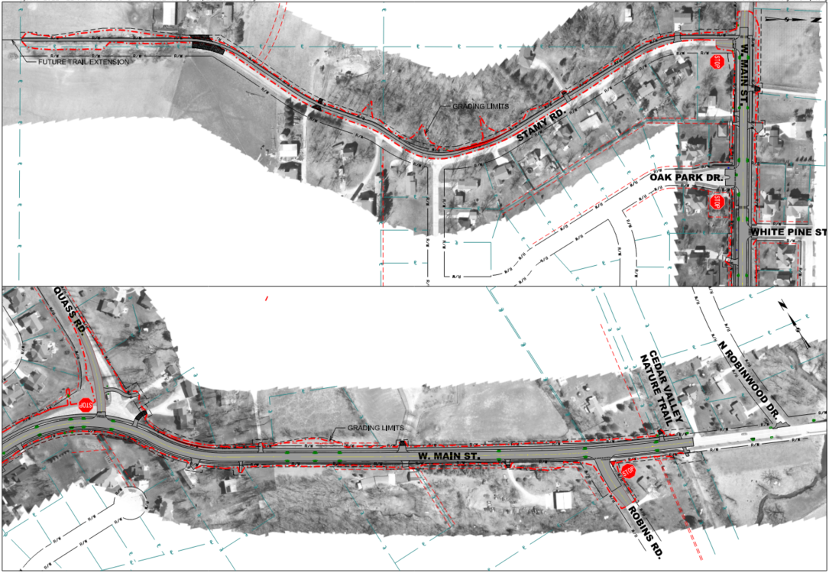
Figure 1: W Main St Project Map

